C:\Users\Siva\AppData\Local\Microsoft\Windows\INetCache\Content.Word\zenith 1138.png

**ETrademine Project**

**Document:**

**Issued on : 11-May-2016**

**Author : Vinod**

**Version : 1.0**

**Copyright**

ã 2015 Zenith Services Inc.

All rights reserved

The recipient receives this document on the condition that the recipient will keep the document confidential and will not use its contents in any form or by any means without the prior written permission of Zenith Services Inc. Moreover, the recipient is not authorised to place this document at the disposal of any third party without the prior written permission of Zenith Services Inc.

If such permission is granted, it will be subject to the condition that the recipient ensures that any recipient of this document, or information contained therein, is held responsible to Zenith Services Inc. for the confidentiality of that information.

Zenith Services Inc. undertakes to treat all information provided by the recipient as confidential.

The General Terms of Zenith Services Inc. apply to this document.

All trademarks used in this document remain the property of their rightful owners.

**Etrademine Project**

These are all Etrademine dependent Projects.

dao

debug

ETrademine

ETrademineCommon

ETrademineDao

EtrademineEntitlement

EtrademineEntitlementCommon

ETrademineEntitlementDao

EtrademineEntitlementServer

ETrademineUtils

EventsClient

EventsCommon

EventsServer

factoryserver

FincadMarketData

FincadPricing

sessionsClient

sessionsCommon

sessionsServer

Tradecommon

TrademineClient

TrademineCommon

Trademineserver

TrademineUtils

windowsUtil

Please check-out these projects in SVN URl in the below process.

**Step-1**

Click on right side mouse.

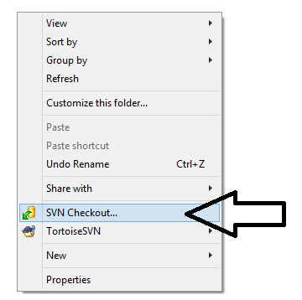

**Step-2**

Click **SVN Checkout..**

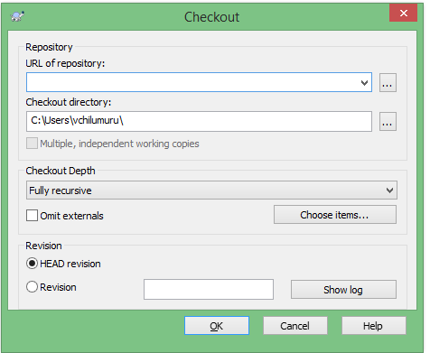

**Step-3**

Copy ETrademine SVN Project URL and paste to **URL of repository:** like this

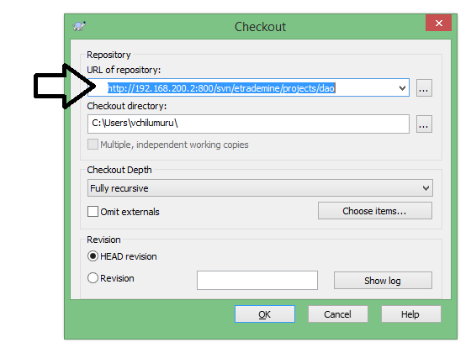

Click **ok**

**Step-4**

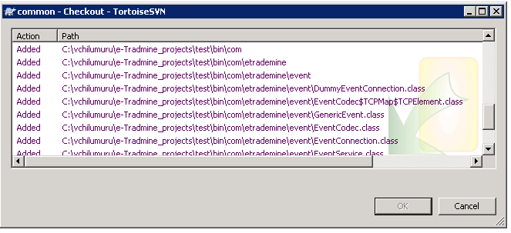

It will Import Project automatically.

**Step-5**

After finishing this click ok button.

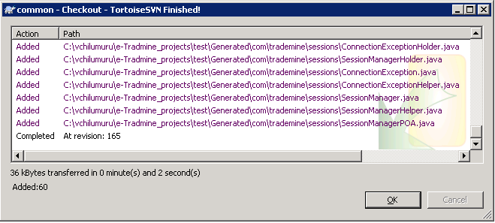

**How to Import Projects Into Eclipse**

**Step-1**

Click right side of mouse there is button called **Import** click this.

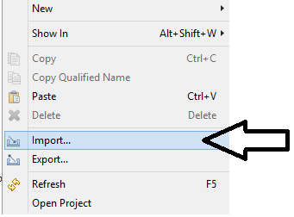

**Step-2**

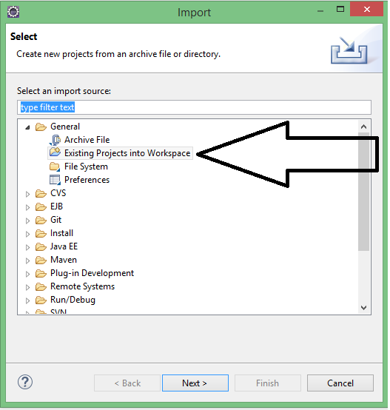

Double click on **Existing Projects into Workspace.**

**Step-3**

Click on **Browse** button.

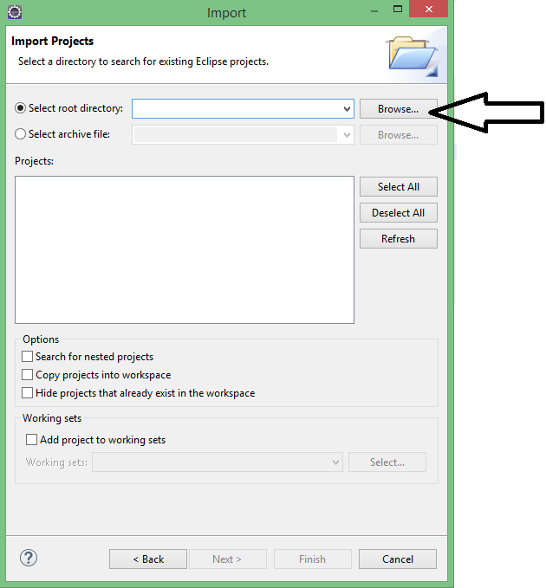

**Step-4**

Select the ETrademine Workspace.

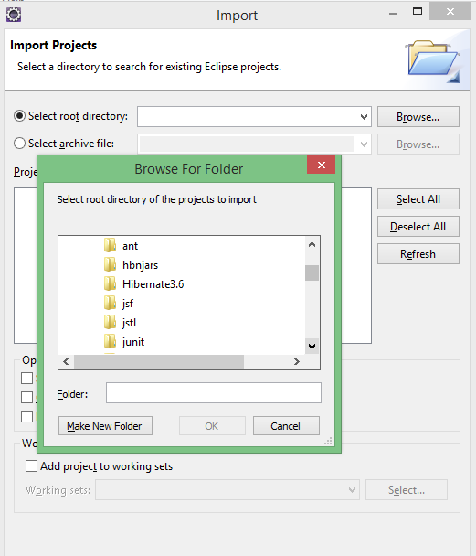

Select

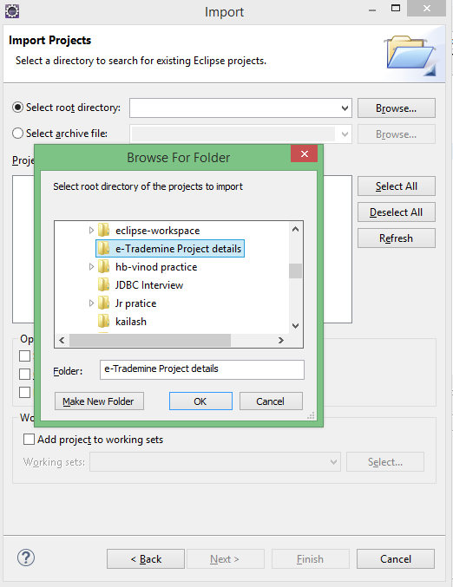

Click ok.

**Step-5**

select Your dependency Projects.

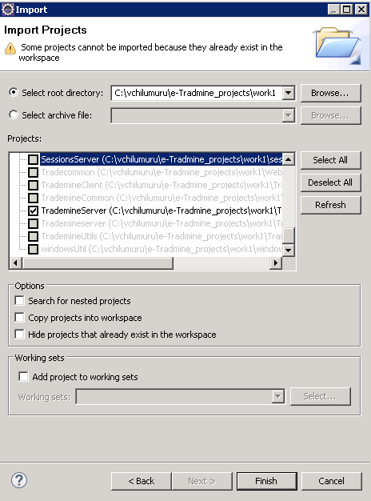

click **Finish.**

**Step-6**

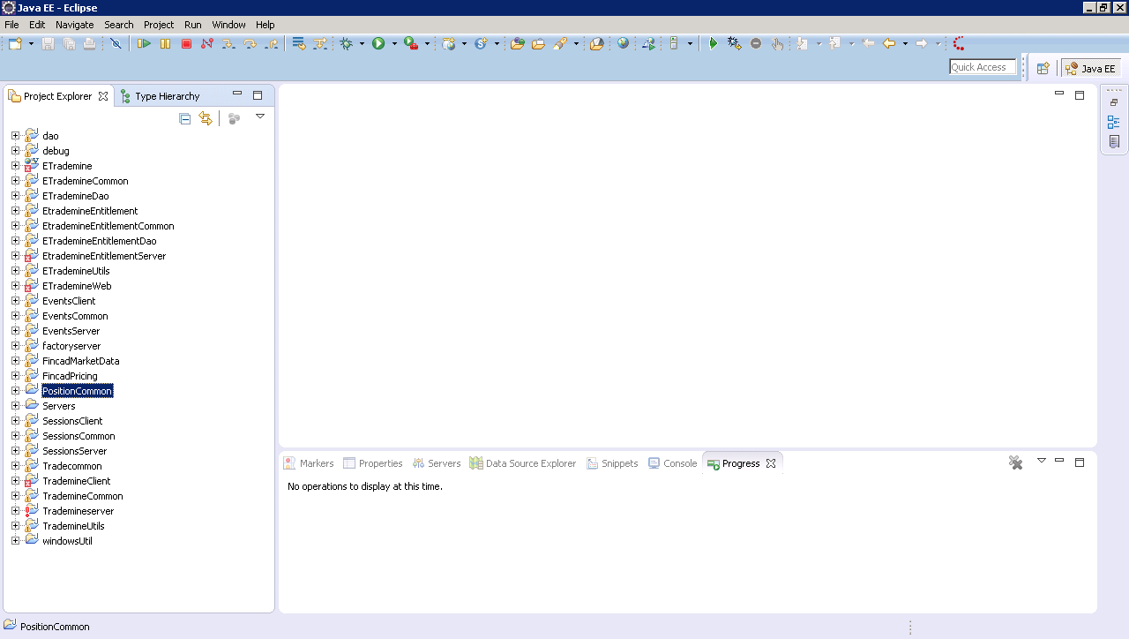

------------------------------------------------

**Dependent Projects and SVN URL's**

------------------------------------------------

**dao**

http://192.168.200.2:800/svn/etrademine/projects/dao

**debug**

http://192.168.200.2:800/svn/etrademine/projects/debug

**ETrademine**

http://192.168.200.2:800/svn/etrademine-sencha/ETrademine

**AppManagerClientInterface**

http://192.168.200.2:800/svn/etrademine/projects/AppManager/ClientInterface

**ETrademineCommon**

http://192.168.200.2:800/svn/etrademine-sencha/ETrademineCommon

**ETrademineDao**

http://192.168.200.2:800/svn/etrademine-sencha/ETrademineDao

**EtrademineEntitlement**

http://192.168.200.2:800/svn/etrademine-sencha/EtrademineEntitlement

**EtrademineEntitlementCommon**

http://192.168.200.2:800/svn/etrademine-sencha/EtrademineEntitlementCommon

**ETrademineEntitlementDao**

http://192.168.200.2:800/svn/etrademine-sencha/ETrademineEntitlementDao

**EtrademineEntitlementServer**

http://192.168.200.2:800/svn/etrademine-sencha/EtrademineEntitlementServer

**ETrademineUtils**

http://192.168.200.2:800/svn/etrademine-sencha/ETrademineUtils

**ETrademineWeb**

http://192.168.200.2:800/svn/web-projects/ETrademineWeb

**EventsClient**

http://192.168.200.2:800/svn/etrademine/projects/Event/client

**EventsCommon**

http://192.168.200.2:800/svn/etrademine/projects/Event/common

**EventsServer**

http://192.168.200.2:800/svn/etrademine/projects/Event/server

**factoryserver**

http://192.168.200.2:800/svn/etrademine/projects/factory/server

**facorycommon**

http://192.168.200.2:800/svn/etrademine/projects/factory/common

**FincadMarketData**

http://192.168.200.2:800/svn/etrademine-sencha/FincadMarketData

**FincadPricing**

http://192.168.200.2:800/svn/etrademine-sencha/FincadPricing

**sessionsClient**

http://192.168.200.2:800/svn/etrademine/projects/sessions/client

**sessionsCommon**

http://192.168.200.2:800/svn/etrademine/projects/sessions/common

**sessionsServer**

http://192.168.200.2:800/svn/etrademine/projects/sessions/server

**Tradecommon**

http://192.168.200.2:800/svn/web-projects/Tradecommon

**TrademineClient**

http://192.168.200.2:800/svn/etrademine/projects/Trademine/client

**TrademineCommon**

http://192.168.200.2:800/svn/etrademine/projects/Trademine/common

**Trademineserver**

http://192.168.200.2:800/svn/etrademine/projects/Trademine/server

**TrademineUtils**

http://192.168.200.2:800/svn/etrademine-sencha/TrademineUtils

**windowsUtil**

http://192.168.200.2:800/svn/etrademine/projects/windowsUtil

-------------------------------------------------------------------------------------------------------------------------------------

**dao:**

In this project dependency **jars** are in the below

**Dependent jars**

|  |  |
| --- | --- |
| FactoryCommon.jar | postgresql-9.3-1102.jdbc3.jar |
| postgresql-9.4.1208.jre6.jar | Debug.jar |

-------------------------------------------------------------------------------------------------------------------------------------

**debug**

In this project dependency **jars** are in the below

**Dependent jars**

Null

-------------------------------------------------------------------------------------------------------------------------------------

**ETrademine**

In this project dependency **Projects** and **jars** are in the below

**Dependent jars**

---------

-------------------------------------------------------------------------------------------------------------------------------------

**ETrademineCommon**

In this project dependency **jars** are in the below

**Dependent jars**

Null

-------------------------------------------------------------------------------------------------------------------------------------

**ETrademineDao**

In this project dependency **jars** are in the below

**Dependent jars**

|  |  |
| --- | --- |
| commons-collections-2.1.1.jar | postgresql-9.3-1102.jdbc3.jar  postgresql-9.4.1208.jre6.jar |
| commons-fileupload-1.2.1.jar | rhino-1.6R7.jar |
| commons-collections-2.1.1.jar | slf4j-api-1.6.1.jar |
| commons-fileupload-1.2.1.jar | validation-api-1.0.0.GA.jar |
| commons-io-1.4.jar | vbjorb.jar |
| commons-lang-2.3.jar | gson-2.2.1.jar |
| commons-logging-1.0.4.jar | hibernate-annotations.jar |
| directjngine.2.2.jar | hibernate-commons-annotations.jar |
| hibernate-core.jar | hibernate-jpa-2.0-api-1.0.1.Final.jar |
| hibernate-validator.jar | hibernate3.jar |
| jaas.jar | javassist-3.12.0.GA.jar |
| jaxen-1.1-beta-4.jar | log4j-1.2.16.jar |
| org.apache.commons.collections.jar | FincadPricing.jar |
| ETrademineCommon.jar | EtrademineEntitlement.jar |
| EtrademineEntitlementCommon.jar | ETrademineEntitlementDao.jar |
| ETrademineUtils.jar | TrademineCommon.jar |

-------------------------------------------------------------------------------------------------------------------------------------

**EtrademineEntitlement**

In this project dependency **jars** are in the below

**Dependent jars**

|  |  |
| --- | --- |
| commons-fileupload-1.2.1.jar | commons-fileupload-1.2.1.jar |
| commons-lang-2.3.jar | gson-2.2.1.jar |
| directjngine.2.2.jar | hibernate-annotations.jar |
| hibernate-core.jar | hibernate-commons-annotations.jar |
| hibernate-jpa-2.0-api-1.0.1.Final.jar | hibernate-validator.jar |
| hibernate3.jar | jaas.jar |
| log4j-1.2.16.jar | postgresql-9.3-1102.jdbc3.jar |
| postgresql-9.4.1208.jre6.jar | rhino-1.6R7.jar |
| yuicompressor-2.4.2.jar |  |
| ETrademineCommon.jar | EtrademineEntitlementCommon.jar |
| ETrademineDao.jar | ETrademineEntitlementDao.jar |
| EtrademineEntitlement.jar | ETrademineUtils.jar |
| TrademineCommon.jar | Dao.jar |

-------------------------------------------------------------------------------------------------------------------------------------

**EtrademineEntitlementCommon**

In this project dependency **jars** are in the below

**Dependent jars**

|  |  |
| --- | --- |
| commons-fileupload-1.2.1.jar | commons-io-1.4.jar |
| commons-lang-2.3.jar | commons-logging-1.0.4.jar |
| directjngine.2.2.jar | gson-2.2.1.jar |
| hibernate-annotations.jar | hibernate-commons-annotations.jar |
| hibernate-core.jar | hibernate-jpa-2.0-api-1.0.1.Final.jar |
| hibernate-validator.jar | hibernate3.jar |
| jaas.jar | log4j-1.2.16.jar |
| postgresql-9.3-1102.jdbc3.jar | postgresql-9.4.1208.jre6.jar |
| rhino-1.6R7.jar | yuicompressor-2.4.2.jar |
| ETrademineCommon.jar | EtrademineEntitlement.jar |
| ETrademineDao.jar | ETrademineEntitlementDao.jar |
| TrademineCommon.jar |  |

-------------------------------------------------------------------------------------------------------------------------------------

**ETrademineEntitlementDao**

In this project dependency **jars** are in the below

**Dependent jars**

|  |  |
| --- | --- |
| commons-fileupload-1.2.1.jar | commons-io-1.4.jar |
| commons-lang-2.3.jar | directjngine.2.2.jar |
| gson-2.2.1.jar | hibernate-commons-annotations.jar |
| hibernate-annotations.jar | hibernate-core.jar |
| hibernate-jpa-2.0-api-1.0.1.Final.jar | hibernate-validator.jar |
| jaas.jar | log4j-1.2.16.jar |
| postgresql-9.3-1102.jdbc3.jar | postgresql-9.4.1208.jre6.jar |
| rhino-1.6R7.jar | yuicompressor-2.4.2.jar |
| EtrademineEntitlement.jar | ETrademineUtils.jar |

**EtrademineEntitlementServer**

In this project dependency **jars** are in the below

**Dependent jars**

|  |  |
| --- | --- |
| AppManagerClientInterface.jar | commons-fileupload-1.2.1.jar |
| commons-io-1.4.jar | commons-lang-2.3.jar |
| commons-logging-1.0.4.jar | directjngine.2.2.jar |
| factoryserver.jar | gson-2.2.1.jar |
| fincad_f3_java_6_2.jar | fincad_f3_java_explicit_6_2.jar |
| jargs-1.0.jar | log4j-1.2.16.jar |
| postgresql-9.3-1102.jdbc3.jar | postgresql-9.4.1208.jre6.jar |
| rhino-1.6R7.jar | yuicompressor-2.4.2.jar |
| ETrademineCommon.jar | ETrademineDao.jar |
| EtrademineEntitlement.jar | EtrademineEntitlementCommon.jar |
| ETrademineEntitlementDao.jar | ETrademineUtils.jar |
| EventsCommon.jar | EventsServer.jar |
| TrademineCommon.jar |  |

-------------------------------------------------------------------------------------------------------------------------------------

**ETrademineUtils**

In this project dependency **jars** are in the below

**Dependent jars**

|  |  |
| --- | --- |
| commons-collections4-4.1.jar | commons-fileupload-1.2.1.jar |
| commons-io-1.4.jar | commons-lang-2.3.jar |
| commons-logging-1.0.4.jar | directjngine.2.2.jar |
| gson-2.2.1.jar | hibernate-annotations.jar |
| hibernate-commons-annotations.jar | hibernate-core.jar |
| hibernate-jpa-2.0-api-1.0.1.Final.jar | hibernate-validator.jar |
| hibernate3.jar | jargs-1.0.jar |
| javassist-3.6.jar | log4j-1.2.16.jar |
| org.apache.commons.collections.jar | rhino-1.6R7.jar |
| postgresql-9.3-1102.jdbc3.jar | postgresql-9.4.1208.jre6.jar |
| slf4j-api-1.6.1.jar | validation-api-1.0.0.GA.jar |
| yuicompressor-2.4.2.jar |  |
| ETrademineCommon.jar | ETrademineDao.jar |
| EtrademineEntitlement.jar | EtrademineEntitlementCommon.jar |
| ETrademineEntitlementDao.jar | TrademineCommon.jar |

-------------------------------------------------------------------------------------------------------------------------------------

**EventsClient**

In this project dependency **jars** are in the below

**Dependent jars**

|  |  |
| --- | --- |
| FactoryCommon.jar |  |
| Debug.jar | EventsCommon.jar |
| sessionsCommon.jar |  |

-----------------------------------------------------------------------------------------------------------------------------------

**EventsCommon**

In this project dependency **jars** are in the below

**Dependent jars**

|  |  |
| --- | --- |
| FactoryCommon.jar | log4j-1.2.16.jar |
| sessionsCommon.jar | Debug.jar |

-------------------------------------------------------------------------------------------------------------------------------------

**EventsServer**

In this project dependency **jars** are in the below

**Dependent jars**

|  |  |  |
| --- | --- | --- |
| FactoryCommon.jar |  | |
| sessionsCommon.jar | Debug.jar | |
| EventsCommon.jar | sessionsServer.jar |

------------------------------------------------------------------------------------------------------------------------------------

**factoryserver**

In this project dependency **jars** are in the below

**Dependent jars**

|  |  |
| --- | --- |
| FactoryCommon.jar | log4j-1.2.16.jar |
| Debug.jar |  |

------------------------------------------------------------------------------------------------------------------------------------

**FincadMarketData**

In this project dependency **jars** are in the below

**Dependent jars**

|  |  |
| --- | --- |
| commons-fileupload-1.2.1.jar | commons-io-1.4.jar |
| commons-lang-2.3.jar | gson-2.2.1.jar |
| directjngine.2.2.jar | hibernate-annotations.jar |
| hibernate-commons-annotations.jar | hibernate-core.jar |
| hibernate-jpa-2.0-api-1.0.1.Final.jar | hibernate-validator.jar |
| hibernate3.jar | jaas.jar |
| jargs-1.0.jar | javassist-3.6.jar |
| log4j-1.2.16.jar | postgresql-9.3-1102.jdbc3.jar |
| postgresql-9.4.1208.jre6.jar | rhino-1.6R7.jar |
| yuicompressor-2.4.2.jar |  |
| ETrademineCommon.jar | ETrademineDao.jar |
| EtrademineEntitlement.jar | EtrademineEntitlementCommon.jar |
| ETrademineEntitlementDao.jar | TrademineCommon.jar |

-------------------------------------------------------------------------------------------------------------------------------------

**FincadPricing**

In this project dependency **jars** are in the below

**Dependent jars**

|  |  |
| --- | --- |
| ant-1.6.2.jar | ant-antlr-1.6.2.jar |
| ant-junit-1.6.2.jar | ant-launcher-1.6.2.jar |
| ant-swing-1.6.2.jar | antlr-2.7.4.jar |
| antlr-2.7.6.jar | commons-fileupload-1.2.1.jar |
| commons-io-1.4.jar | commons-lang-2.3.jar |
| directjngine.2.2.jar | fincad_f3_java_6_2.jar |
| fincad_f3_java_explicit_6_2.jar | gson-2.2.1.jar |
| hibernate-annotations.jar | hibernate-commons-annotations.jar |
| hibernate-core.jar | hibernate-jpa-2.0-api-1.0.1.Final.jar |
| hibernate-validator.jar | hibernate3.jar |
| jaas.jar | log4j-1.2.16.jar |
| postgresql-9.3-1102.jdbc3.jar | postgresql-9.4.1208.jre6.jar |
| rhino-1.6R7.jar | yuicompressor-2.4.2.jar |
| ETrademineCommon.jar | ETrademineEntitlementDao.jar |
| EtrademineEntitlement.jar | EtrademineEntitlementCommon.jar |
| ETrademineEntitlementDao.jar | TrademineCommon.jar |

-------------------------------------------------------------------------------------------------------------------------------------

**SessionsClient**

In this project dependency **jars** are in the below

**Dependent jars**

|  |  |
| --- | --- |
| FactoryCommon.jar | s11_chart.jar |
| SessionsCommon.jar | Debug.jar |

-------------------------------------------------------------------------------------------------------------------------------------

**SessionsCommon**

In this project dependency **jars** are in the below

**Dependent jars**

|  |  |
| --- | --- |
| Debug.jar |  |

-------------------------------------------------------------------------------------------------------------------------------------

**SessionsServer**

In this project dependency **jars** are in the below

**Dependent jars**

|  |  |
| --- | --- |
| FactoryCommon.jar |  |
| SessionsCommon.jar | Tradecommon.jar |
| Dao.jar | Debug.jar |

------------------------------------------------------------------------------------------------------------------------------------

**Tradecommon**

In this project dependency **jars** are in the below

**Dependent jars**

|  |  |
| --- | --- |
| easybeans-uberjar-hibernate-1.2.3.jar |  |

-------------------------------------------------------------------------------------------------------------------------------------

**TrademineClient**

In this project dependency **jars** are in the below

**Dependent jars**

|  |  |
| --- | --- |
| PositionCommon.jar | acme.jar |
| FactoryCommon.jar | jclass.jar |
| EventsClient.jar | EventsCommon.jar |
| EventsServer.jar | SessionsClient.jar |
| SessionsCommon.jar | Tradecommon.jar |
| TrademineCommon.jar | TrademineUtils.jar |
| Debug.jar |  |

-------------------------------------------------------------------------------------------------------------------------------------

**TrademineCommon**

In this project dependency **jars** are in the below

**Dependent jars**

|  |  |
| --- | --- |
| FactoryCommon.jar |  |
| EventsCommon.jar | EtrademineEntitlementCommon.jar |
| Debug.jar | ETrademineCommon.jar |
| EtrademineEntitlement.jar | ETrademineUtils.jar |

-------------------------------------------------------------------------------------------------------------------------------------

**Trademineserver**

In this project dependency **jars** are in the below

**Dependent jars**

|  |  |
| --- | --- |
| acme.jar | ant-1.6.2.jar |
| ant-antlr-1.6.2.jar | ant-junit-1.6.2.jar |
| ant-launcher-1.6.2.jar | ant-swing-1.6.2.jar |
| antlr-2.7.6.jar | antlr-2.7.4.jar |
| AppManagerClientInterface.jar | c3p0-0.8.5.jar |
| cglib-full-2.0.2.jar | cleanimports.jar |
| commons-collections-2.1.1.jar | commons-logging-1.0.4.jar |
| concurrent-1.3.2.jar | connector.jar |
| dom4j-1.5.2.jar | ehcache-1.1.jar |
| FactoryCommon.jar | fincad_f3_java_6_2.jar |
| fincad_f3_java_explicit_6_2.jar | gson-2.2.1.jar |
| hibernate-annotations.jar | hibernate-commons-annotations.jar |
| hibernate-core.jar | hibernate-jpa-2.0-api-1.0.1.Final.jar |
| hibernate-validator.jar | hibernate3.jar |
| jaas.jar | jacc-1_0-fr.jar |
| jakarta-poi-2.5.jar | jargs-1.0.jar |
| jaxen-1.1-beta-4.jar | jboss-common.jar |
| jboss-jmx.jar | jboss-remoting.jar |
| jboss-system.jar | jdbc2_0-stdext.jar |
| jgroups-2.2.7.jar | jpeg.jar |
| jta.jar | junit-3.8.1.jar |
| log4j-1.2.16.jar | mysql-connector-java-3.0.16-ga-bin.jar |
| mysql-connector-java-3.1.6-bin.jar | NetComponents.jar |
| oscache-2.1.jar | postgresql-9.3-1102.jdbc3.jar |
| postgresql-9.4.1208.jre6.jar | proxool-0.8.3.jar |
| s11_chart.jar | slf4j-api-1.6.1.jar |
| swarmcache-1.0rc2.jar | versioncheck.jar |
| xerces-2.6.2.jar | xml-apis.jar |
| ETrademineCommon.jar | ETrademineDao.jar |
| EtrademineEntitlement.jar | EtrademineEntitlementCommon.jar |
| ETrademineEntitlementDao.jar | ETrademineUtils.jar |
| EventsCommon.jar | EventsServer.jar |
| Factoryserver.jar | FincadPricing.jar |
| SessionsServer.jar | Tradecommon.jar |
| TrademineCommon.jar | Dao.jar |
| Debug.jar |  |

-------------------------------------------------------------------------------------------------------------------------------------

**TrademineUtils**

In this project dependency **jars** are in the below

**Dependent jars**

|  |  |
| --- | --- |
| AppManagerClientInterface.jar | FactoryCommon.jar |
| Debug.jar | ETrademineCommon.jar |
| ETrademineDao.jar | EtrademineEntitlement.jar |
| EtrademineEntitlementCommon.jar | ETrademineEntitlementDao.jar |
| EventsCommon.jar | EventsServer.jar |
| TrademineCommon.jar |  |

-------------------------------------------------------------------------------------------------------------------------------------

**WindowsUtil**

In this project dependency **jars** are in the below

**Dependent jars**

|  |  |
| --- | --- |
| Debug.jar |  |